User Manual

FMS^{NG} Application

Shell Energy Marketing and Trading India Private Limited
Project Sponsoring Business

Admin Module

29 FEB 2024
Date

Table of Contents
1. Admin Module Overview 3
1.1. User Interface / Screen Designs 3
2. Menu Network / Screen Navigation 4
2.1. Group – Menu 4
2.2. Group – Access Group 9
2.3. Group – User 12
3. Report Design and Layout 15
4. Auditing 16

Admin Module Overview
FMS^{NG} Application is an efficient ETRM System for Domestic Gas Trading, customized to meet business requirement of Shell Energy Marketing and Trading India Private Limited (SEMTIPL).
FMS^{NG} Admin Module meant to carry out all administrative activities as listed below:
- UI Module, Menu creation
- Access Group Creation and Access Right Management
- User Addition and Management
- Password Management
- Email Support for System Status Reporting
- Debug Tools
- Management Reports and Audit Trails
The Admin Module is more relevant for System Administrators.

User Interface / Screen Designs

FMS^{NG} offers Responsive UI to enable usability via any smart phone, tab and laptop of any screen size. The Menus of Admin module are as below:

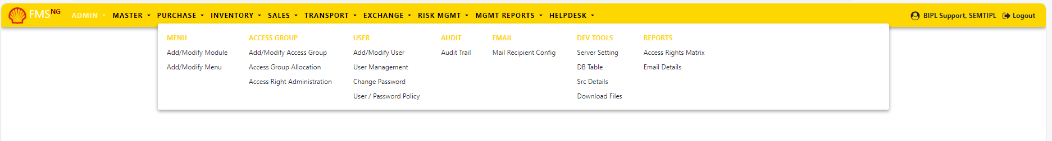

The responsive mode view over iPhone simulation:
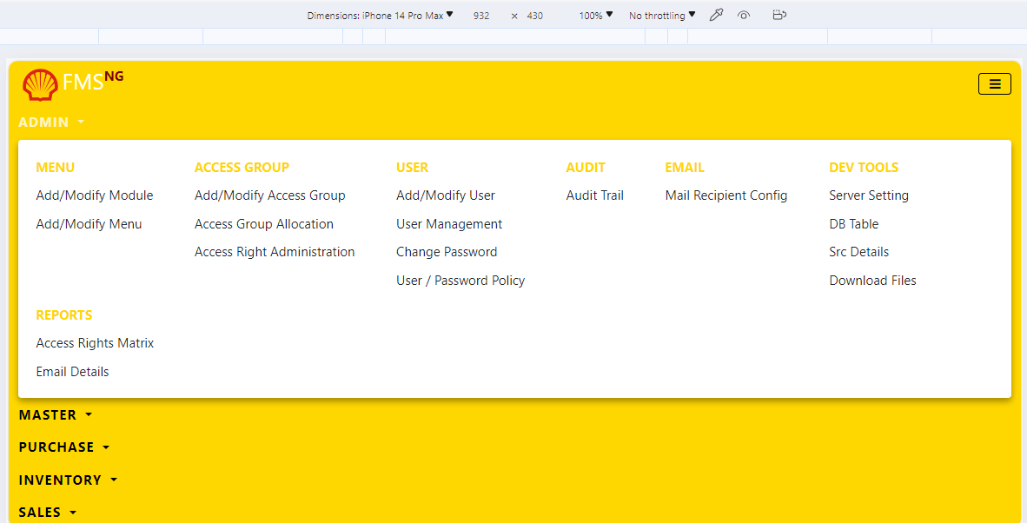

Menu Network / Screen Navigation
Menus in any Module are kept under different Groups for better categorization. The Groups under Admin Module are Menu, Access Group, Users, Audit, Emails, Dev Tools and Reports.

Sub Module – Menu

‘Menu’ Group contains FORMs for exposing different Modules and Menus in the application.

Menu Add/Modify Module

Modules in FMS^{NG} Application added/edited from this FORM by system Administrator.

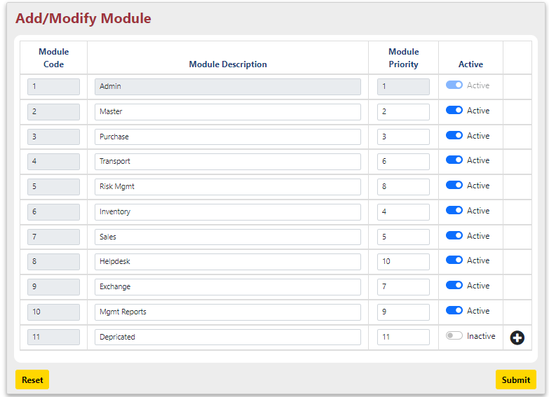

To add a new Module, click on (+) sign at the right below corner and enter Module details:
- Module Code: System generated Unique Code for the Module.
- Module Description: Description about the Module.
- Module Priority: Priority of appearance of the Module in Menu bar.
- Active: Set Active. Inactive Module will not appear in Manu bar.

After inserting all the details, click on “Submit” Button. A dialogue box asking your permission to insert the Module in system appears as shown below:

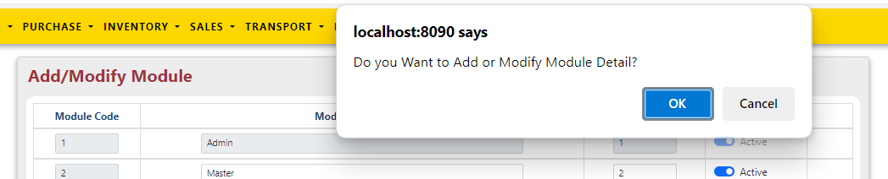

Press Ok. The status of menu insertion in system get displayed on the top of the screen.

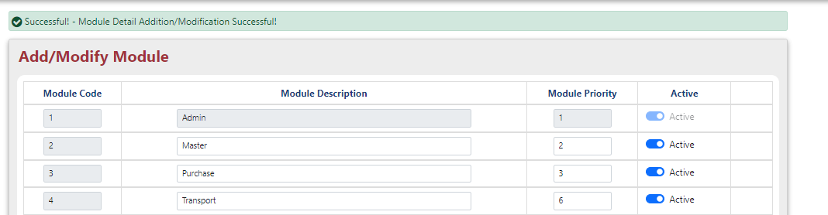

System Admin can only set/alter Module Name, Active status and Priority of appearance in Menu bar.

Menu Add/Modify Menu

System Admin can only add/alter Menus under any Sub Module in FMS^{NG} Application.

Follow below steps to add a menu under any Sub Module:

- Module Name: Select Module, in which Menu is to be inserted. Like Admin, Master etc.

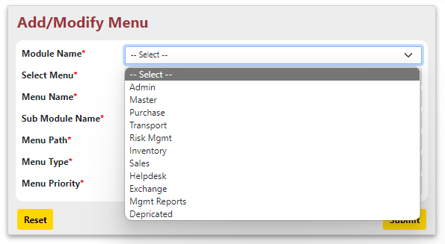

- Select Menu: Keep <New Menu> to add NEW Menu

- Menu Name: Enter Name of the Menu, to be inserted
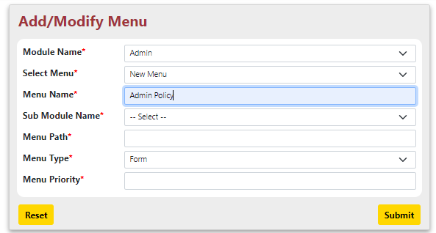

- Sub Module Name: Select Name of the Sub Module under available under Modules.
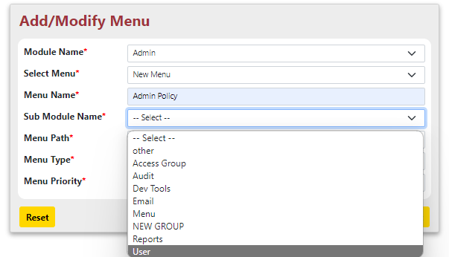

- Sub Module Name: Select ‘Other’ to add new Sub Module under the Module
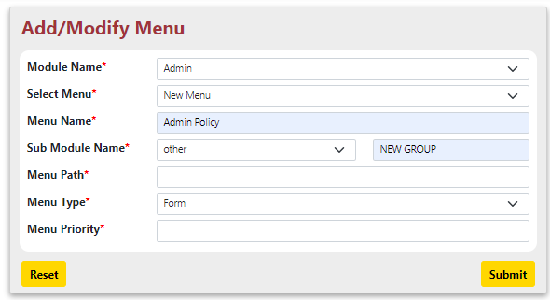

- Menu Path: Associate Menu with JSP source to display.
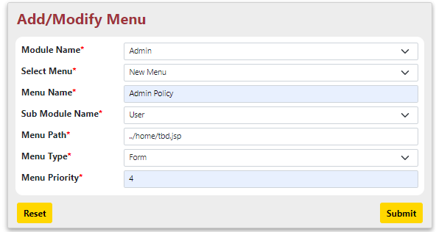
- Menu Type: Select Menu Type – FORM | REPORT
- Menu Priority: Specify Menu Priority of appearance inside the Group

After inserting all the details, click on “Submit” Button to insert the menu in system. A dialogue box asking your permission to insert detail about Menu appears as shown below:
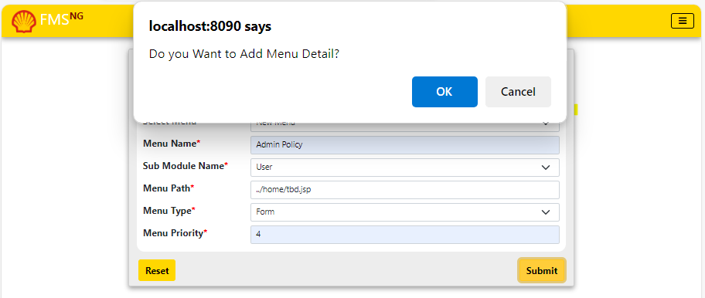

Press Ok. The status of menu insertion in system get displayed on the top of the screen.
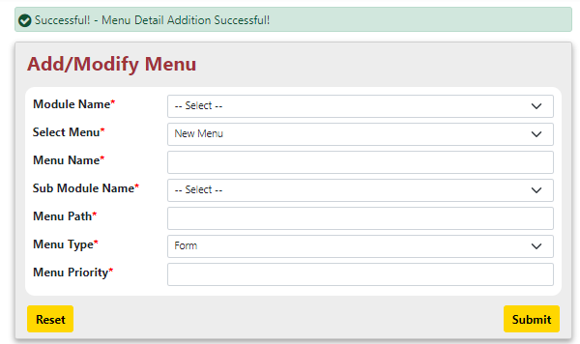
To edit details of any existing menu, follow below steps:
- Module Name: Select Module, in which Menu is to be inserted. Like Admin, Master etc.
- Select Menu: Select the existing menu from drop down

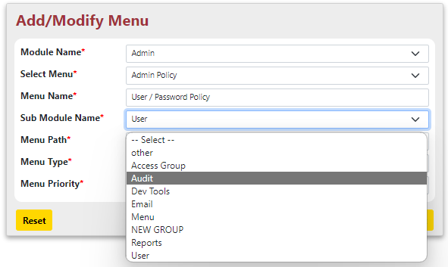
- Menu Name: Edit Menu Name to alter
- Group Name: Select Group Name to Alter as needed
- Menu Path: Alter Menu Path as needed to associate JSP source to display.
- Menu Type: Alter Menu Type – FORM | REPORT as needed
- Menu Priority: Alter Menu Priority of appearance inside the Group as needed

After inserting all the details, click on “Submit” Button to insert the menu in system. A dialogue box asking your permission to update detail about Menu. Press Ok.

The status of menu insertion in system get displayed on the top of the screen.

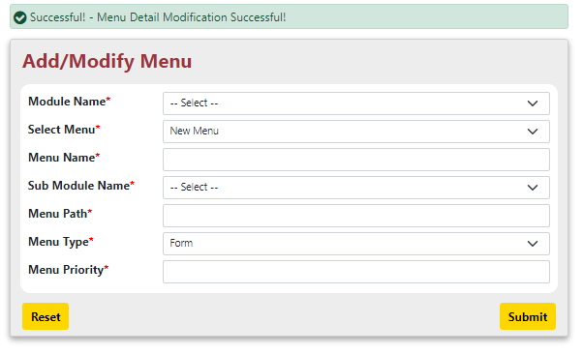

Sub Module – Access Group

Access Group captures most critical system administration menus in FMS^{NG}.
Based on Access Group association, Module | Menu access and rights of any user is controlled.
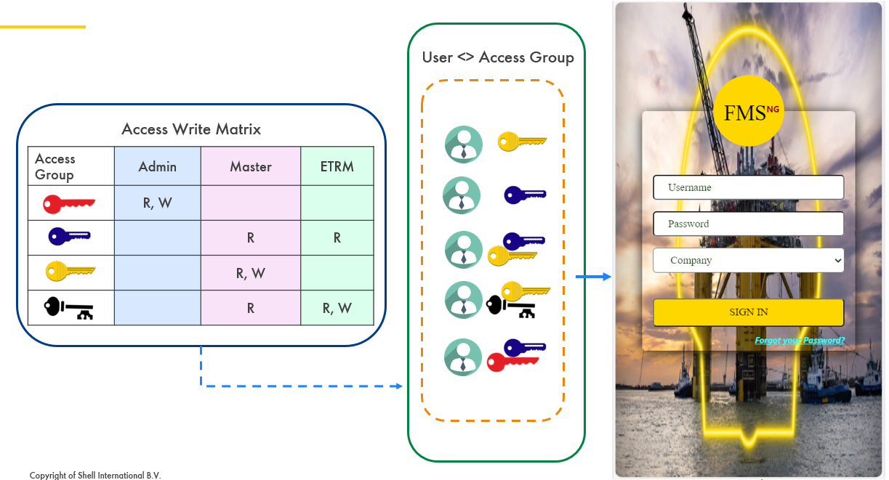


Simulates Admin user having Read and Write access for Admin Module. And have only Read access for other functional Modules.

Access Group Add/Modify Access Group

System Admin can only add/alter Access Group in FMS^{NG} Application. User Access Group are added as per Shell User Access Management Policy.

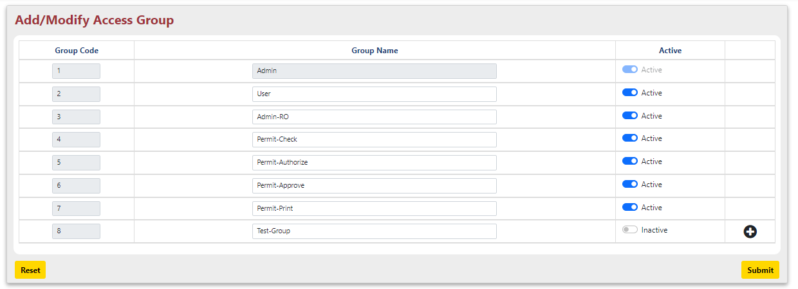

To add a new Access Group, click on (+) sign at the right below corner and enter details:
- Group Code: System generated Unique Code for the Access Group.
- Group Name: Name of Access Group.
- Active: Set Active. Inactive Access Group will overrule any access rights assigned.
After inserting all the details, click on “Submit” Button. A dialogue box asking your permission to insert the Access Group in system appears. Press Ok. The status of menu insertion in system get displayed on the top of the screen.

System Admin can only set/alter Access Group Name and Access Group Active status.

Access Group Access Right Administration

Access Right Administration is about granting different access rights to Access Group over any menu under any Sub Moedule of any Module. System Admin can only add/alter Access Group Rights for any Access Group in FMS^{NG} Application.

To add/alter Access Group Rights for any Access Group, select specific detail:
- Access Group: Select Access Group to add/alter Rights.
- Module: Select Module.
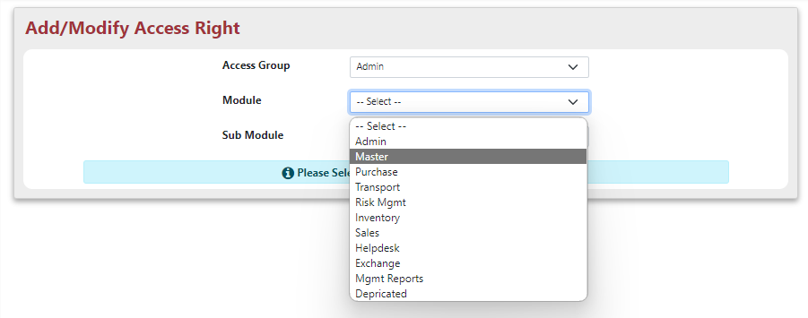
- Select Sub Module: Select Sub Module.
- All Menus under the Sub-Module will be listed
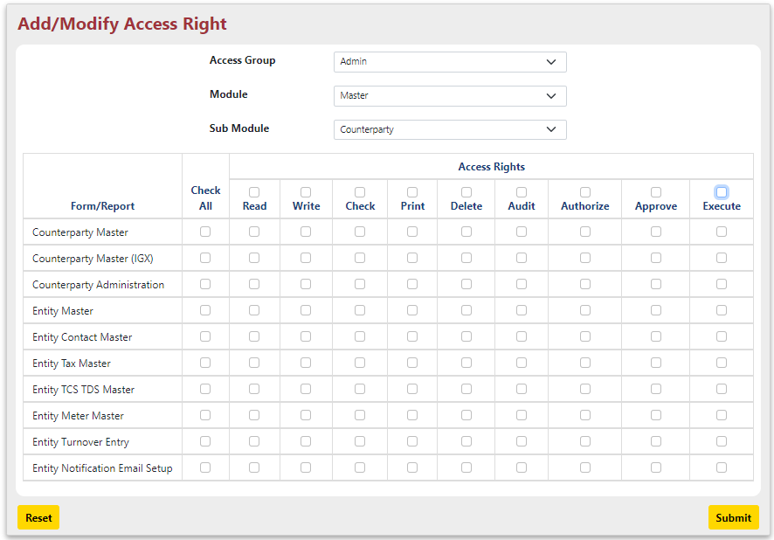
- Check/Uncheck rights to alter rights associated with selected Access Group.
- After inserting all the details, click on “Submit” Button. A dialogue box asking your permission to insert the Module in system appears as shown below:
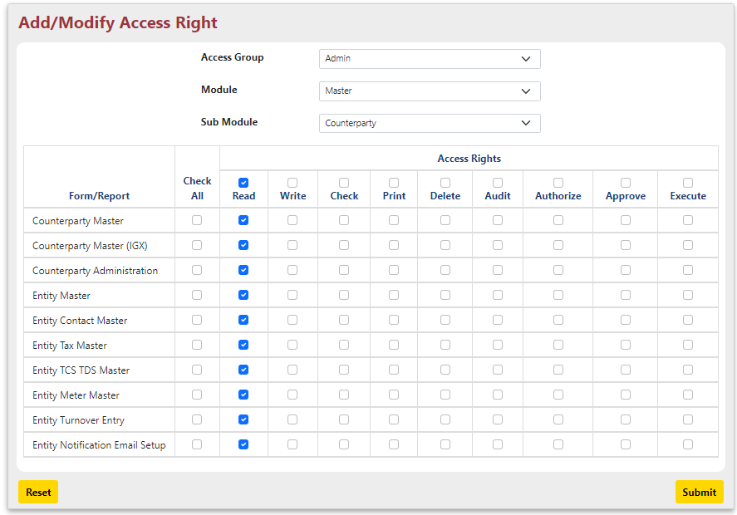

Press Ok. The status of menu insertion in system get displayed on the top of the screen.

Note: If there is no Access right given for any menu / all menu in a module, the menu will not appear in Manu bar for user associated with those Access group.

Access Group Access Group Allocation
Access Group Allocation is all about associating Access Groups with Users of FMS^{NG} to perform their assigned activities. Again System Admin can only add/alter Access Group association for any User in FMS^{NG} Application.

Follow below steps to associate Access Group to FMS^{NG} User:
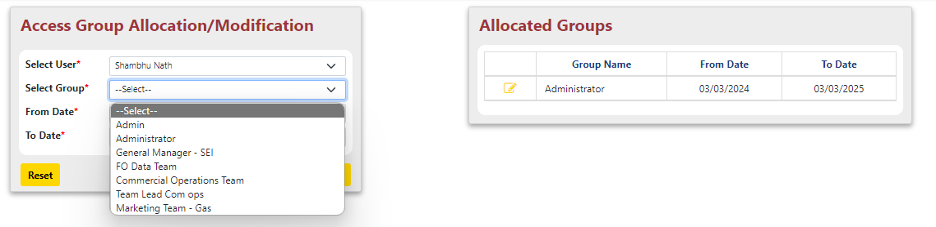
- Select User: Select User for whom Access Group to be added
- Select Group: Select Access Group for association.
- From Date & To Date: Specify the during for which the association will be valid

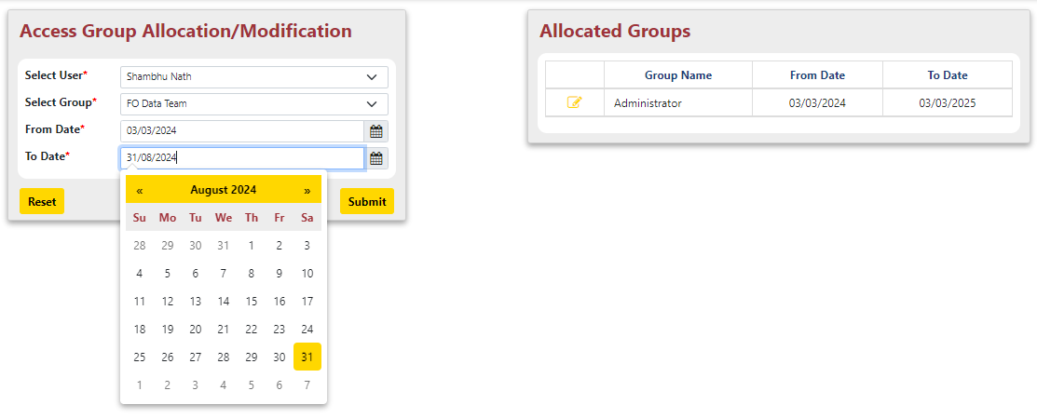
After inserting all the details, click on “Submit” Button. A dialogue box asking your permission to associate the Access Group with User in system appears.
Press Ok. The status of menu insertion in system get displayed on the top of the screen.

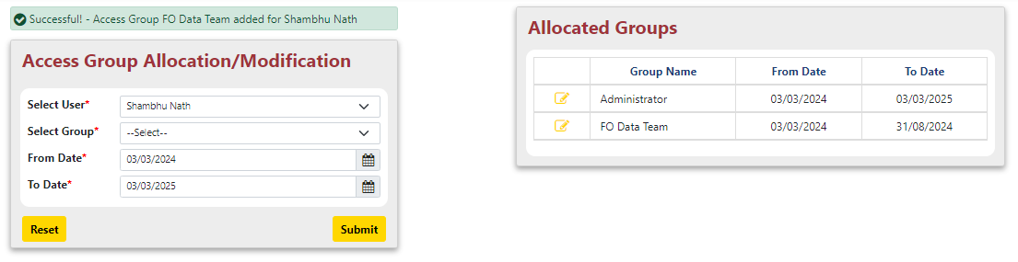
The Right Screen displays the newly Associated Access Group detail for the User.

To edit details of any allocated Access Group of any User, follow below steps:
- Module Name: Select Module, in which Menu is to be inserted. Like Admin, Master etc.
- Select Menu: Select the existing menu from drop down

Sub Module – User

User Add/Modify User

User User Management

User Change Password

User User / Password Policy

Sub Module – Audit

2.2.1.10 Audit → Audit Trail

Sub Module – Email

2.2.1.11 Email → Mail Recipient Config

Sub Module – Dev Tools

2.2.1.12 Dev Tools → Server Setting
List FMSNG specific settings

2.2.1.13 Dev Tools → DB Table

List FMSNG Database Tables
Fetch restricted data for debug purpose.

2.2.1.14 Dev Tools → Src Details

List FMSNG Source Files
Fetch/Upload restricted files for debug purpose.

2.2.1.15 Dev Tools → Download Files

User will be able to access specific folders and download Report / specific files.

Sub Module – Reports

2.2.1.16 Reports → Access Rights Matrix

2.2.1.17 Reports → Email Details
Add diagram showing screen navigation and routing through the screens/windows.

Report Design and Layout
All Report details are covered as a part of section 2.3 Menu Network / Screen Navigation
The detailing done FMS^{NG} Module wise to enable better workflow understanding.

Auditing

List and describe various audit procedures to meet control, reporting and retention period requirements for operational and management reports.

Ability to identify all audit information by user identification, network terminal, date, time and data accessed or changed.

